Linguists page

Careers
Join our growing team of translation, interpreting, and transcription professionals and become part of our expert linguist network.
We offer a flexible and rewarding work environment and a wide variety of opportunities.
You will be a freelance interpreter or translator and you can choose to work as per your work schedule and be liable to pay your own tax.
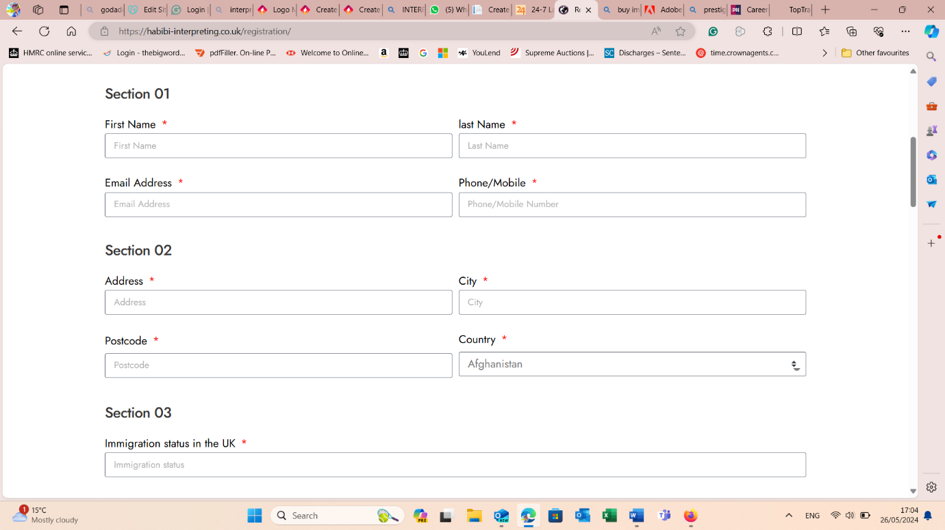
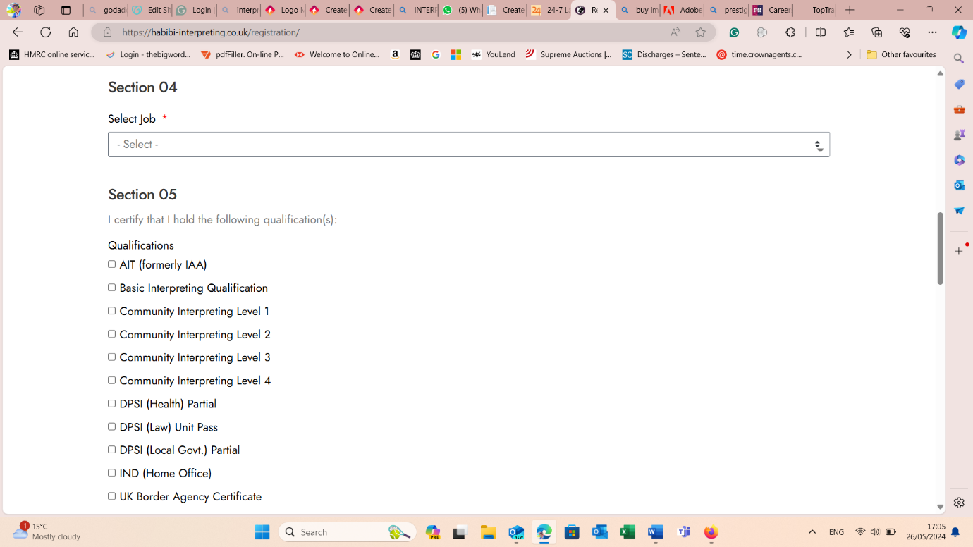
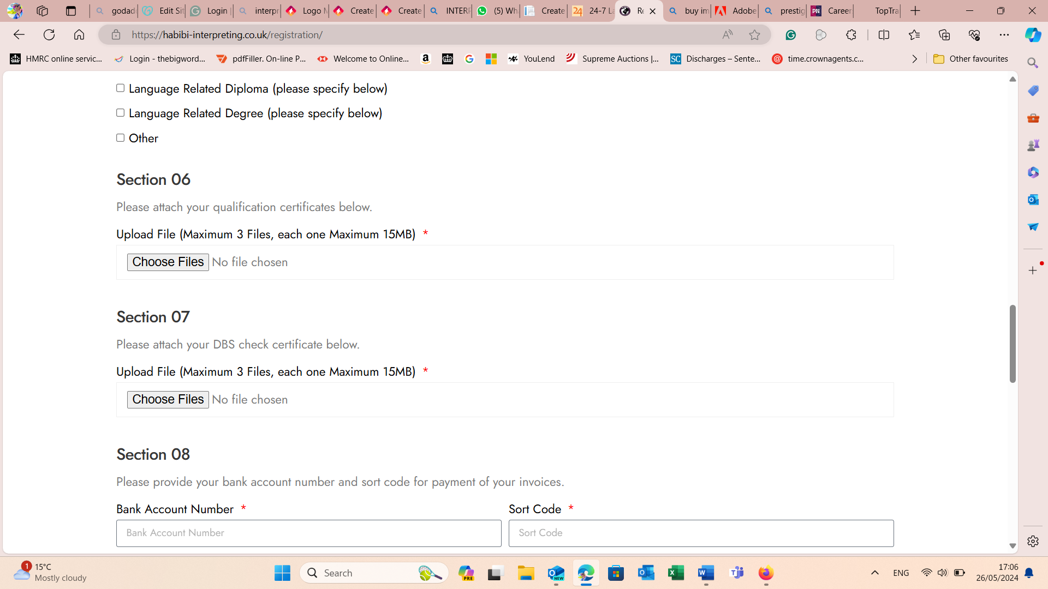
(please don’t add section 8 – bank details

I have read and agree to the Terms and Conditions
Submit – add submit button

